SMART ENERGY METER FOR DOMESTIC PURPOSE

This product is a PCB(Printed circuit Board) for my project Smart energy meter.

Abstract:

Energy saving is the most important and challenging issue. Smart power meter is used in domestic electric power distribution system. The integration of the Node-MCU,PZEM sensor, Relay and provides the system as Smart Power Monitoring system. Smart power meter provides data for optimization and reduce the power consumption. This system communicates with embedded controller and ESP8266 module to transmit the data. Domestic consumers get benefited through this system.

COMPONENTS REQUIRED:

1. PZEM-004T
2. ESP8266(NodeMCU)
3. Resistors
4. Electrolytic Capacitor
5. 5V adapter
6. Pin Header
7. Female PCB Header
8. 5V relay module
9. LCD display

WORKING:

NodeMCU is an open source IoT platform based on ESP8266 which can connect objects and let data transfer using the Wi-Fi protocol.

PZEM-004T is an electronic module that functions to measure: Voltage, Current, Power, Frequency, Energy and Power Factors

The Node-MCU is connected to PZEM sensor which calculates the units of power used and Relay controls the MCB. We set the limit of power consumed and if it reached the limit the relays turns on and switches the MCB off to stop the power supply. Relay will turn the MCB off when it detects that the supply and return current are not balanced.

The load wire is inserted inside the PZEM sensor which calculates the power used displays it in LCD. We can see the power consumed by using the HTML page, by copying the IP address and pasting it in the chrome browser. A static IP address is created for this. It displays the power consumed, current, and voltage etc., used. By using the mobile phone we can see the amount of power consumed in our home or work place and conserve the electricity accordingly.

Business Plan: Yes

This is cost efficient than the existing models available in the market and is user friendly.

What problem are you trying to address?

The conservation of energy is very much need in this modern world. It is very important for our future generation too. This project allows us to be conscious about the future and save power for further use..

What differentiates your idea from similar solutions/Idea?

Similar projects like this usually use internet connection for transmission of data. The main advantage of our project is that we can see the data from the sensor without the use of internet connection. The budget is also low compared to other existing models. The usage of Node-MCU allows us to operate the Power meter even without the use of internet. Node-MCU connects through the local network which includes a Wi-Fi modem, mobile phone

Beneficiaries of the project?

Currently, conservation of energy is very much important in this modern world. Hence using this technology we can analyse the usage of power in our work place or at home and plan accordingly to save power. We can analyze the data without the use of internet connection.

Scope of the project?

The main scope of this project is to develop a cost affordable, energy conserving, user friendly interface.

PROJECT STATUS: COMPLETED

PICTURES:

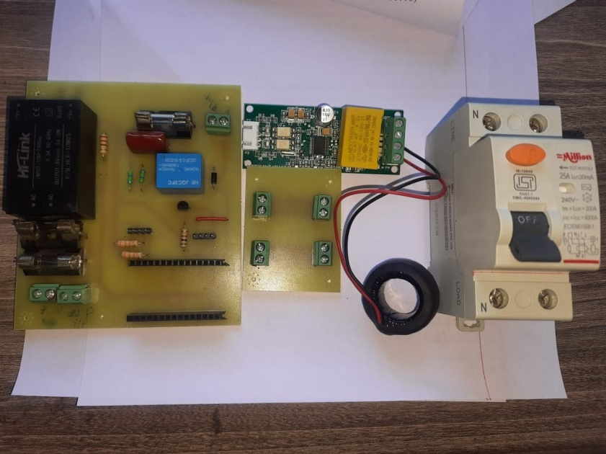

1.CIRCUIT

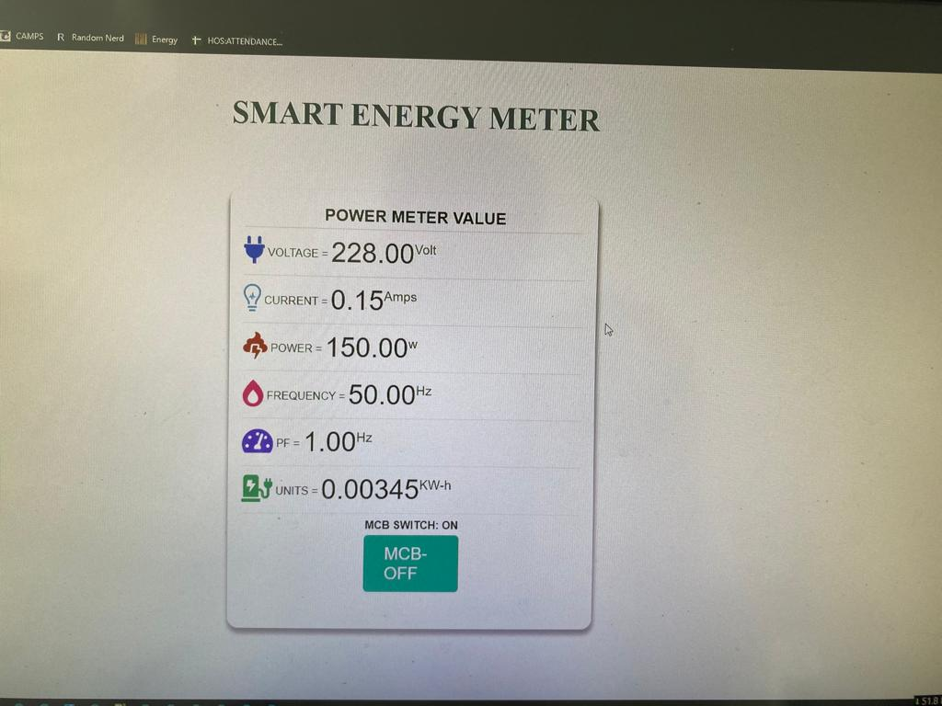

2.HTML PAGE

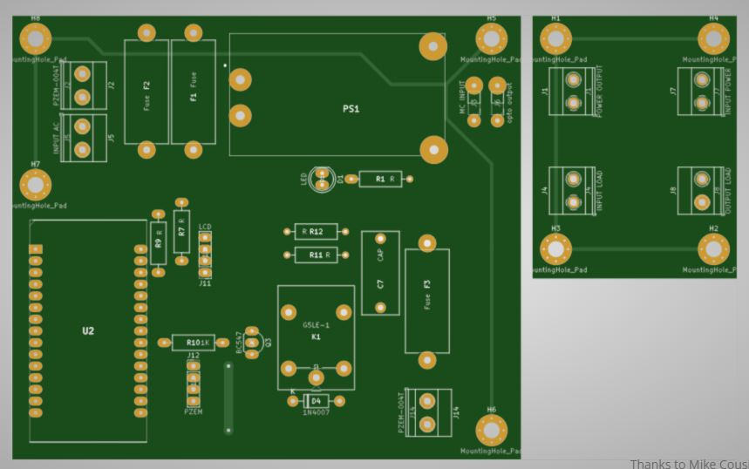

3.PCB LAYOUT

VIDEO LINK:

<https://youtu.be/CcO0pPjPvhU>